API Gateway

AWS API Gateway is a managed service from Amazon Web Services used to create, publish, secure, and monitor APIs.
It acts as a front door for applications to access backend services such as:
- AWS Lambda
- EC2
- ECS
- External HTTP services

🚀 Why We Use API Gateway
API Gateway helps you:
- Create REST APIs and HTTP APIs
- Connect frontend applications to backend services
- Secure APIs using authentication
- Handle traffic management
- Monitor API usage

⚙️ How It Works
Client Request → API Gateway → Backend Service → Response
Example:
Browser → API Gateway → Lambda Function → Response

📌 Types of APIs
Type | Purpose
REST API | Full-featured APIs
HTTP API | Lightweight and cheaper
WebSocket API | Real-time communication

🔥 Common Use Cases
- Serverless applications
- Mobile app backends
- Microservices architecture
- Public APIs
- Internal enterprise APIs

Create API Gateway with Lambda
Open API Gateway
Choose API Type
Select:
- HTTP API
Click Build.
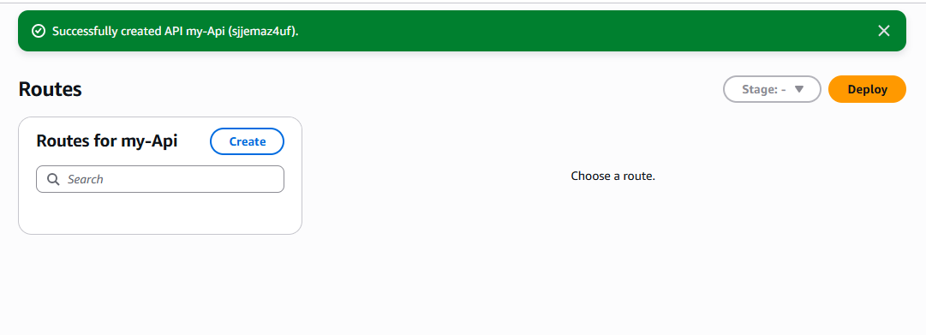

Configure Integration
Choose:
- Lambda
Select your Lambda function.
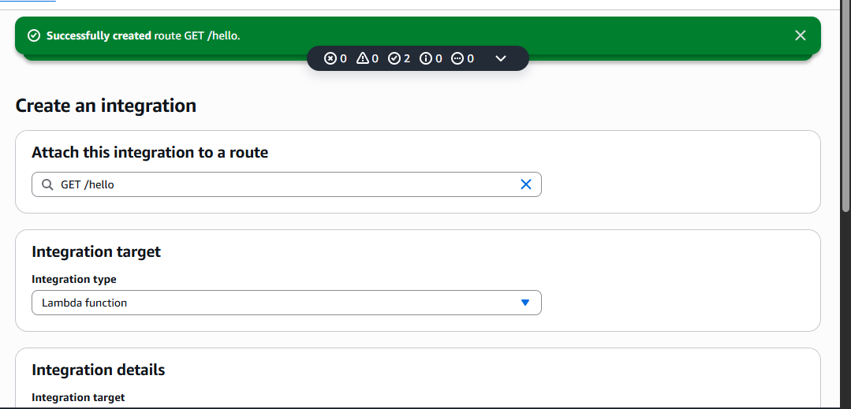

Deploy API
- Stage name: dev
Click Create.
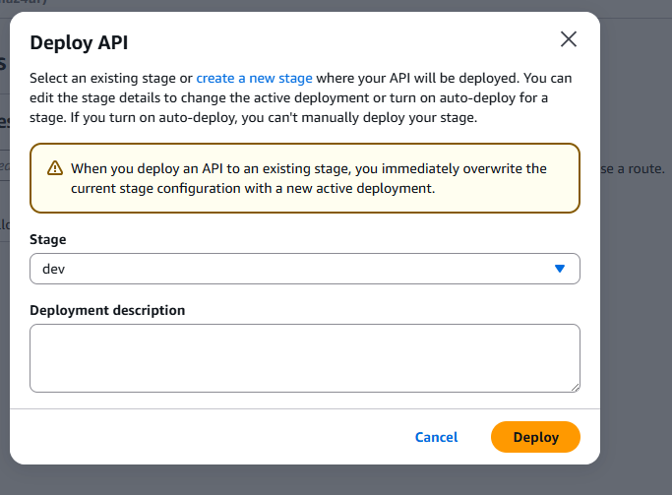
Test API
You will get an endpoint like:
